Link: <https://www.youtube.com/watch?v=wZHtZ_VJGKI&list=PL8p2I9GklV47TMMnPzqnkCtSOS3ebr4O7>

Way to organize data so that we can use this data efficiently.

Ans. Data means project data, with the help of that we can manage data, sorting, searching, merging, deletion etc.

Unstructured data Example [3,2,5,3,5,6,8,9] Red

Efficient Data Example [2,3,3,5,5,6,8,9] Green

---------------------------------------------------------------------------------

What is Algorithm?

* Steps or a process to arrange data is called Algorithm.

[3,2,5,3,5,6,8,9] Red

[2,3,3,5,5,6,8,9] Green

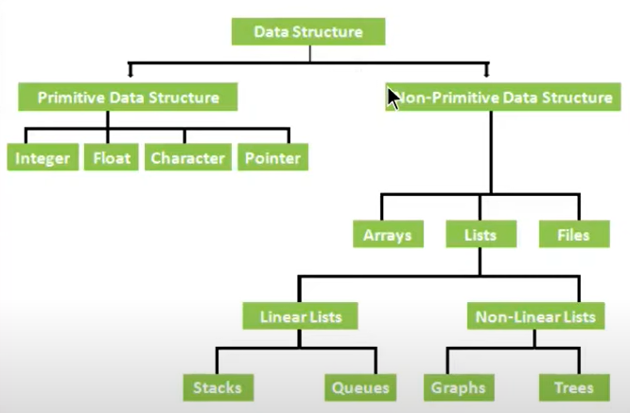

**Operations of Data Structure**

Different Algorithm can be use options

* Traversal ( To check the value )
* Insertion ( to insert the value )
* Deletion ( to deletion value )
* Searching ( to find the value )
* Sorting ( to arrange the value such as low to high )
* Merging ( to merge the arrays )

**Operation of Data Structure**

* Array
* Stack
* Queue
* Tree
* Graph
* Insertion
* Recursion
* Search
* Sorting
* Merge
* Map
* Set

**Course ++**

* Logical Part

# Nested Loops

# Low and Highest Values

# Objects

# Update Specific Value

# Etc.

# 2 Link: <https://www.youtube.com/watch?v=20GIloOLBQ0&list=PL8p2I9GklV47TMMnPzqnkCtSOS3ebr4O7&index=2>

**Array Traversing and Accessing**

**Ans: Accessing means to checkout each element of the array.**

**Traversing means to access specific element of the array.**

* Make HTML Page write Basic Array
* Traversing with loop
* Accessing Elements
* Access element with test input and button
* Validations

<!DOCTYPE html>

<html lang="en">

<head>

    <meta charset="UTF-8">

    <meta http-equiv="X-UA-Compatible" content="IE=edge">

    <meta name="viewport" content="width=device-width, initial-scale=1.0">

    <title>Array Traversing</title>

    <script>

        let data = [9, 45, 2, 8, 45, 23, 7, 78, 0, 11, 41, 77]

        // for(let i = 0;i < data.length; i++){

        //     document.write(`Array ${i} is ${data[i]}<br>`)

        // }

        // let x = 10;

        // document.write(data[10])

        function getElement() {

            let el = document.getElementById('element').value

            if (el < data.length && typeof parseInt(el) === "number") {

                alert(data[el])

            } else {

                alert("Please enter valid input")

            }

        }

    </script>

</head>

<body>

<input type="text" id="element" />

    <button onclick="getElement()">Get Element</button>

</body>

</html>

# 3 Link : <https://www.youtube.com/watch?v=aPRn4TBnI20&list=PL8p2I9GklV47TMMnPzqnkCtSOS3ebr4O7&index=3>

**Insert Element in Array**

* Understand issue and solution with whiteboard.
* Make array, define the position.
* Use Loop to insert new element.
* Insert element with text input and button.
* Insert Element with by default function.

<!DOCTYPE html>

<html lang="en">

  <head>

    <title>Insert Element in Array</title>

    <script>

      // let data =[60,30,10,67,40];

      // let newEl= 70;

      // let position=2;

      // console.warn(data)

      // for(let i=data.length-1;i>=0;i--){

      //     // console.warn(data[i])

      //     if(i>=position)

      //     {

      //         data[i+1]=data[i];

      //         if(i==position)

      //         {

      //             data[i]=newEl;

      //         }

      //     }

      // }

      // console.warn(data)

      function insertEl() {

        let data = [60, 30, 10, 67, 40];

        let newEl = document.getElementById('newEl').value;

        newEl = parseInt(newEl)

        let position = document.getElementById('position').value

        console.warn(data);

        for (let i = data.length - 1; i >= 0; i--) {

          // console.warn(data[i])

          if (i >= position) {

            data[i + 1] = data[i];

            if (i == position) {

              data[i] = newEl;

            }

          }

        }

        console.warn(data)

      }

    </script>

  </head>

  <body>

    <input type="text" id="position" placeholder="enter position" />

    <input type="text" id="newEl" placeholder="enter new element" />

    <button onclick="insertEl()">Insert</button>

  </body>

</html>